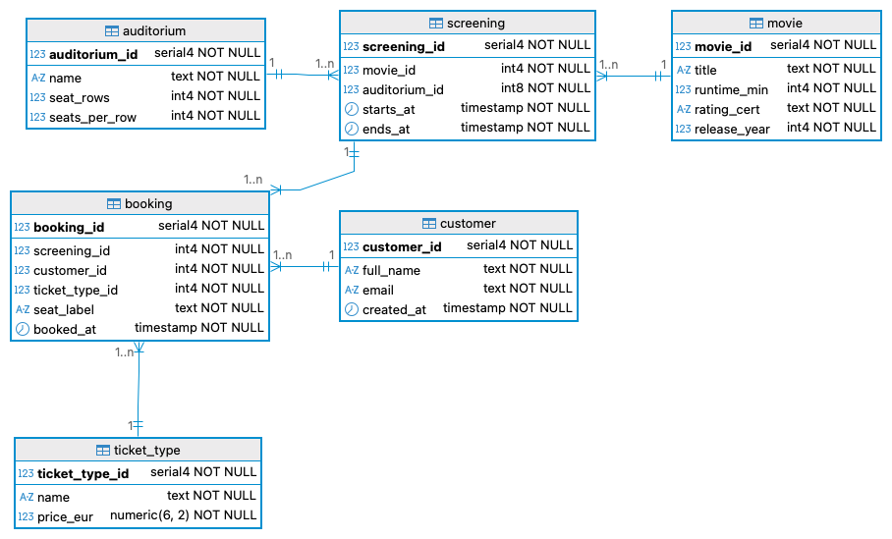
Consider the schema presented and answer the questions.

1 (85% of students answered correctly)
The following query:
SELECT COUNT(*) FROM screening;
A) Returns one row with the count of all screenings
B) Returns one row per screening
C) Returns the number of distinct movies only
D) Fails because COUNT cannot be used without GROUP BY
Correct answer: A
Explanation: count(*) counts all rows in the table, including null values, and always returns one single value, unless a group by is used.

2. (65% of students answered correctly)
The following query:
SELECT MAX(AVG(price_eur)) FROM ticket_type;
A) Returns the maximum average price
B) Returns an error as nested aggregates are not allowed
C) Returns one value per ticket type
D) Runs successfully but returns wrong result
Correct answer: B
Explanation: SQL does not allow nesting aggregate functions directly in the same select level. You must compute the average in a subquery.

3. (69% of students answered correctly)
The following query will:
SELECT
COUNT(*) FILTER(WHERE ticket_type_id=1) AS "Adult",
COUNT(*) FILTER(WHERE ticket_type_id=2) AS "Student"
FROM booking;
A) Count all tickets twice
B) Separate counts by condition in the same result
C) Require GROUP BY
D) Be an invalid syntax
Correct answer: B
Explanation: The FILTER clause applies a condition inside an aggregate. You get both counts in one row, each using a different condition. No GROUP BY needed because there is no grouping attribute.

4. (99% of students answered correctly)
According to the query, which seat would be labelled as a front seat?
SELECT seat_label,
CASE WHEN seat_label LIKE 'Z%' THEN 'Front'
WHEN seat_label LIKE 'D%' THEN 'Middle'
ELSE 'Back'
END AS zone
FROM booking;
A) A10
B) D5
C) C3
D) Z1
Correct answer: D
Explanation: LIKE 'Z%' selects seat labels starting with "Z". Only Z1 matches.

5. (80% of students answered correctly)
The following query returns:
SELECT screening_id
FROM booking
WHERE ticket_type_id IN
(SELECT ticket_type_id FROM ticket_type WHERE price_eur>10);
A) Screenings where all tickets cost €10
B) Screenings where at least one ticket above €10 exists
C) Screenings with all tickets below than €10
D) Syntax error
Correct answer: B
Explanation: The subquery returns ticket types priced above €10. The outer query selects screenings where at least one booking uses one of these types.

6. (82% of students answered correctly)
What does the keyword EXISTS check?
A) If a subquery returns any row
B) If a column exists in a table
C) If a view exists
D) If a constraint exists
Correct answer: A
Explanation: EXISTS(subquery) is true if the subquery returns at least one row. It doesn't check table existence.

7. (97% of students answered correctly)
What will this subquery-based update do?
UPDATE ticket_type
SET price_eur = (SELECT AVG(price_eur) FROM ticket_type)
WHERE price_eur IS NULL;
A) Delete NULL rows
B) Replace NULL prices with the average price
C) Set all prices in euros to NULL
D) Select the average price of all prices
Correct answer: B
Explanation: The subquery calculates the average price of all ticket_types. Only rows with price_eur IS NULL are updated to that average.

8. (88% of students answered correctly)
The following query:
SELECT title, runtime_min
FROM movie
WHERE runtime_min > ALL
(SELECT runtime_min FROM movie WHERE rating_cert='PG');
Finds:
A) Shortest PG films
B) Movies longer than every PG film
C) Movies shorter than any PG film
D) All PG films
Correct answer: B
Explanation: > ALL (subquery) means the runtime must be greater than every value returned. Thus the query returns movies longer than all PG movies.

9. (93% of students answered correctly)
The command
GRANT SELECT, INSERT ON booking TO frontdesk;
A) Allow row frontdesk to create a view
B) Gives read and insert rights to role frontdesk
C) Removes privileges from role frontdesk
D) Backs up data
Correct answer: B
Explanation: GRANT adds privileges. Here the role gets permission to read and insert rows in booking.

10. (89% of students answered correctly)
Example of SQL injection protection:
A) String concatenation of inputs
B) Parameterised queries with placeholders
C) Disabling authentication
D) Using DELETE without WHERE
Correct answer: B
Explanation: Parameterised queries separate code from values, eliminating injection risk. String concatenation is unsafe.

11. (89% of students answered correctly)
In database normalisation, a partial dependency means:
A) Non-key attributes depend only on part of a composite key
B) Attribute depends on the whole key
C) Non-key attributes depend on part of the non-key attributes only
D) Duplicate primary key
Correct answer: A
Explanation: A partial dependency exists when a non-key attribute depends on part of a composite primary key (not the whole key).

12. (82% of students answered correctly)
A transitive dependency occurs when:
A) Attribute depends on another non-key attribute
B) Attribute depends on part of a composite key
C) During a transition, all attributes depend on the primary key
D) The database has no foreign keys
Correct answer: A
Explanation: A non-key attribute depends on another non-key attribute, which depends on the PK.

13. (91% of students answered correctly)
The following command:
SELECT table_name
FROM information_schema.tables
WHERE table_schema='cinema';
A) Shows table metadata
B) Deletes tables
C) Backs up schema
D) Lists all users
Correct answer: A
Explanation: The query returns metadata: the names of all tables inside the schema “cinema”.

14. (94% of students answered correctly)
What is the purpose of information_schema.columns?
A) Holds data values of all columns
B) Contains metadata (column names, types, nullability)
C) Shows data types only
D) Stores backup copies
Correct answer: B
Explanation: It stores metadata about each column: name, type, nullability, default values, etc.

15. (67% of students answered correctly)
The following query:
SELECT screening_id, seat_label, COUNT(*)
FROM booking
GROUP BY screening_id, seat_label
HAVING COUNT(*)>1;
A) Lists repeated seats per screening
B) Counts total seats
C) Deletes duplicates
D) Inserts rows
Correct answer: A
Explanation: Grouping by screening_id, seat_label and counting identifies duplicate seat bookings within the same screening.

16. (67% of students answered correctly)
Which query selects customers with at least two bookings?
A) SELECT c.customer_id, c.full_name
FROM customer c JOIN booking b USING(customer_id)
GROUP BY c.customer_id, c.full_name
HAVING COUNT(*) >= 2;
B) SELECT c.customer_id, c.full_name
FROM customer c WHERE COUNT(*) >= 2;
C) SELECT DISTINCT c.customer_id, c.full_name
FROM customer c JOIN booking b USING(customer_id)
WHERE COUNT(*) >= 2;
D) SELECT customer_id, full_name FROM customer WHERE customer_id IN (SELECT customer_id FROM booking WHERE COUNT(*)>=2);
Correct answer: A
Explanation: Uses a join, groups per customer, and selects only those with at least 2 rows in booking.

17. (78% of students answered correctly)
Which query selects movies longer than every G/PG movie?
A) SELECT title FROM movie WHERE runtime_min > ANY (SELECT runtime_min FROM movie WHERE rating_cert IN ('G','PG'));
B) SELECT title FROM movie WHERE runtime_min > ALL (SELECT runtime_min FROM movie WHERE rating_cert IN ('G','PG'));
C) SELECT title FROM movie WHERE runtime_min >= ANY (SELECT MAX(runtime_min) FROM movie WHERE rating_cert IN ('G','PG'));
D) SELECT title FROM movie WHERE runtime_min > (SELECT MIN(runtime_min) FROM movie WHERE rating_cert IN ('G','PG'));
Correct answer: B
Explanation: runtime_min > ALL (...) requires exceeding every runtime in the subquery.

18. (35% of students answered correctly)
Which row can be used to display each auditorium name and its total capacity?
A) SELECT name, SUM(seat_rows * seats_per_row) AS capacity FROM auditorium
GROUP BY name;
B) SELECT name, seat_rows * seats_per_row AS capacity FROM auditorium;
C) SELECT name, seat_rows + seats_per_row AS capacity FROM auditorium;
D) SELECT DISTINCT name, seat_rows * seats_per_row AS capacity FROM auditorium;
Correct answer: B
Explanation: Capacity is calculated per auditorium by multiplying: seat_rows * seats_per_row. The query shows one row per auditorium with its computed capacity. No aggregation needed.

